Maven wit TypeScript

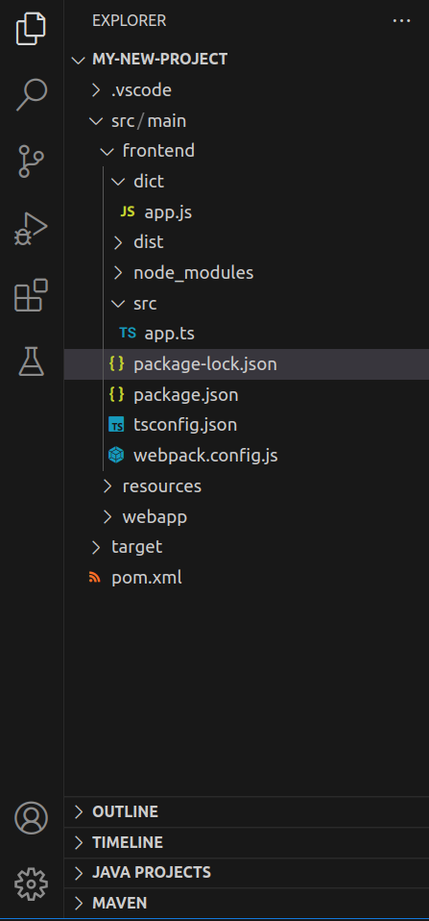

Example 1:
mvn archetype:generate -DgroupId=com.example -DartifactId=my-project -DarchetypeArtifactId=maven-archetype-webapp -DinteractiveMode=false

mvn archetype:generate -DgroupId=com.example -DartifactId=my-project -DarchetypeGroupId=org.apache.maven.archetypes -DarchetypeArtifactId=maven-archetype-quickstart -DinteractiveMode=false

In frontEnd folder:

npx tsc –init

npm init

pom.xml
<project xmlns="http://maven.apache.org/POM/4.0.0"
xmlns:xsi="http://www.w3.org/2001/XMLSchema-instance"
xsi:schemaLocation="http://maven.apache.org/POM/4.0.0 http://maven.apache.org/maven-v4_0_0.xsd">
<modelVersion>4.0.0</modelVersion>
<groupId>com.example</groupId>
<artifactId>my-new-project</artifactId>
<packaging>war</packaging>
<version>1.0-SNAPSHOT</version>
<name>my-new-project Maven Webapp</name>
<url>http://maven.apache.org</url>

<dependencies>
<!-- https://mvnrepository.com/artifact/com.github.eirslett/frontend-maven-plugin -->
<dependency>
<groupId>com.github.eirslett</groupId>
<artifactId>frontend-maven-plugin</artifactId>
<version>1.12.1</version>
</dependency>
</dependencies>

<build>
<plugins>
<plugin>
<groupId>com.github.eirslett</groupId>
<artifactId>frontend-maven-plugin</artifactId>
<version>1.12.1</version>
<configuration>
<workingDirectory>src/main/frontend</workingDirectory>
<installDirectory>target/frontend</installDirectory>
</configuration>
<executions>
<execution>
<id>install node and npm</id>
<goals>
<goal>install-node-and-npm</goal>
</goals>
<configuration>
<!-- <skip>true</skip> -->
<nodeVersion>v18.16.0</nodeVersion>
<npmVersion>9.5.1</npmVersion>
<extraInstallCommands>
<installCommand>install typescript ts-loader --save-dev</installCommand>
</extraInstallCommands>
</configuration>
</execution>
<execution>
<id>npm install</id>
<goals>
<goal>npm</goal>
</goals>
<configuration>
<arguments>install</arguments>
</configuration>
</execution>
<execution>
<id>npm build</id>
<goals>
<goal>npm</goal>
</goals>
<configuration>
<arguments>run build</arguments>
</configuration>
</execution>
</executions>
</plugin>
</plugins>
</build>
</project>

package.json:
{
"name": "frontend",
"version": "1.0.0",
"description": "",
"main": "dict/app.js",
"scripts": {
"build": "webpack --config webpack.config.js",
"test": "echo \"Error: no test specified\" && exit 1"
},
"devDependencies": {
"webpack-cli": "^4.9.1"
},
"keywords": [],
"author": "",
"license": "ISC"
}
tsconfig.json:
{
"compilerOptions": {
/* Visit https://aka.ms/tsconfig to read more about this file */

/* Projects */
// "incremental": true, /* Save .tsbuildinfo files to allow for incremental compilation of projects. */
// "composite": true, /* Enable constraints that allow a TypeScript project to be used with project references. */
// "tsBuildInfoFile": "./.tsbuildinfo", /* Specify the path to .tsbuildinfo incremental compilation file. */
// "disableSourceOfProjectReferenceRedirect": true, /* Disable preferring source files instead of declaration files when referencing composite projects. */
// "disableSolutionSearching": true, /* Opt a project out of multi-project reference checking when editing. */
// "disableReferencedProjectLoad": true, /* Reduce the number of projects loaded automatically by TypeScript. */

/* Language and Environment */
"target": "es2016", /* Set the JavaScript language version for emitted JavaScript and include compatible library declarations. */
// "lib": [], /* Specify a set of bundled library declaration files that describe the target runtime environment. */
// "jsx": "preserve", /* Specify what JSX code is generated. */
// "experimentalDecorators": true, /* Enable experimental support for TC39 stage 2 draft decorators. */
// "emitDecoratorMetadata": true, /* Emit design-type metadata for decorated declarations in source files. */
// "jsxFactory": "", /* Specify the JSX factory function used when targeting React JSX emit, e.g. 'React.createElement' or 'h'. */
// "jsxFragmentFactory": "", /* Specify the JSX Fragment reference used for fragments when targeting React JSX emit e.g. 'React.Fragment' or 'Fragment'. */
// "jsxImportSource": "", /* Specify module specifier used to import the JSX factory functions when using 'jsx: react-jsx*'. */
// "reactNamespace": "", /* Specify the object invoked for 'createElement'. This only applies when targeting 'react' JSX emit. */
// "noLib": true, /* Disable including any library files, including the default lib.d.ts. */
// "useDefineForClassFields": true, /* Emit ECMAScript-standard-compliant class fields. */
// "moduleDetection": "auto", /* Control what method is used to detect module-format JS files. */

/* Modules */
"module": "commonjs", /* Specify what module code is generated. */
"rootDir": "./src", /* Specify the root folder within your source files. */
// "moduleResolution": "node", /* Specify how TypeScript looks up a file from a given module specifier. */
// "baseUrl": "./", /* Specify the base directory to resolve non-relative module names. */
// "paths": {}, /* Specify a set of entries that re-map imports to additional lookup locations. */
// "rootDirs": [], /* Allow multiple folders to be treated as one when resolving modules. */
// "typeRoots": [], /* Specify multiple folders that act like './node_modules/@types'. */
// "types": [], /* Specify type package names to be included without being referenced in a source file. */
// "allowUmdGlobalAccess": true, /* Allow accessing UMD globals from modules. */
// "moduleSuffixes": [], /* List of file name suffixes to search when resolving a module. */
// "resolveJsonModule": true, /* Enable importing .json files. */
// "noResolve": true, /* Disallow 'import's, 'require's or '<reference>'s from expanding the number of files TypeScript should add to a project. */

/* JavaScript Support */
// "allowJs": true, /* Allow JavaScript files to be a part of your program. Use the 'checkJS' option to get errors from these files. */
// "checkJs": true, /* Enable error reporting in type-checked JavaScript files. */
// "maxNodeModuleJsDepth": 1, /* Specify the maximum folder depth used for checking JavaScript files from 'node_modules'. Only applicable with 'allowJs'. */

/* Emit */
// "declaration": true, /* Generate .d.ts files from TypeScript and JavaScript files in your project. */
// "declarationMap": true, /* Create sourcemaps for d.ts files. */
// "emitDeclarationOnly": true, /* Only output d.ts files and not JavaScript files. */
// "sourceMap": true, /* Create source map files for emitted JavaScript files. */
// "outFile": "./", /* Specify a file that bundles all outputs into one JavaScript file. If 'declaration' is true, also designates a file that bundles all .d.ts output. */
"outDir": "./dict", /* Specify an output folder for all emitted files. */
// "removeComments": true, /* Disable emitting comments. */
// "noEmit": true, /* Disable emitting files from a compilation. */
// "importHelpers": true, /* Allow importing helper functions from tslib once per project, instead of including them per-file. */
// "importsNotUsedAsValues": "remove", /* Specify emit/checking behavior for imports that are only used for types. */
// "downlevelIteration": true, /* Emit more compliant, but verbose and less performant JavaScript for iteration. */
// "sourceRoot": "", /* Specify the root path for debuggers to find the reference source code. */
// "mapRoot": "", /* Specify the location where debugger should locate map files instead of generated locations. */
// "inlineSourceMap": true, /* Include sourcemap files inside the emitted JavaScript. */
// "inlineSources": true, /* Include source code in the sourcemaps inside the emitted JavaScript. */
// "emitBOM": true, /* Emit a UTF-8 Byte Order Mark (BOM) in the beginning of output files. */
// "newLine": "crlf", /* Set the newline character for emitting files. */
// "stripInternal": true, /* Disable emitting declarations that have '@internal' in their JSDoc comments. */
// "noEmitHelpers": true, /* Disable generating custom helper functions like '__extends' in compiled output. */
// "noEmitOnError": true, /* Disable emitting files if any type checking errors are reported. */
// "preserveConstEnums": true, /* Disable erasing 'const enum' declarations in generated code. */
// "declarationDir": "./", /* Specify the output directory for generated declaration files. */
// "preserveValueImports": true, /* Preserve unused imported values in the JavaScript output that would otherwise be removed. */

/* Interop Constraints */
// "isolatedModules": true, /* Ensure that each file can be safely transpiled without relying on other imports. */
// "allowSyntheticDefaultImports": true, /* Allow 'import x from y' when a module doesn't have a default export. */
"esModuleInterop": true, /* Emit additional JavaScript to ease support for importing CommonJS modules. This enables 'allowSyntheticDefaultImports' for type compatibility. */
// "preserveSymlinks": true, /* Disable resolving symlinks to their realpath. This correlates to the same flag in node. */
"forceConsistentCasingInFileNames": true, /* Ensure that casing is correct in imports. */

/* Type Checking */
"strict": true, /* Enable all strict type-checking options. */
// "noImplicitAny": true, /* Enable error reporting for expressions and declarations with an implied 'any' type. */
// "strictNullChecks": true, /* When type checking, take into account 'null' and 'undefined'. */
// "strictFunctionTypes": true, /* When assigning functions, check to ensure parameters and the return values are subtype-compatible. */
// "strictBindCallApply": true, /* Check that the arguments for 'bind', 'call', and 'apply' methods match the original function. */
// "strictPropertyInitialization": true, /* Check for class properties that are declared but not set in the constructor. */
// "noImplicitThis": true, /* Enable error reporting when 'this' is given the type 'any'. */
// "useUnknownInCatchVariables": true, /* Default catch clause variables as 'unknown' instead of 'any'. */
// "alwaysStrict": true, /* Ensure 'use strict' is always emitted. */
// "noUnusedLocals": true, /* Enable error reporting when local variables aren't read. */
// "noUnusedParameters": true, /* Raise an error when a function parameter isn't read. */
// "exactOptionalPropertyTypes": true, /* Interpret optional property types as written, rather than adding 'undefined'. */
// "noImplicitReturns": true, /* Enable error reporting for codepaths that do not explicitly return in a function. */
// "noFallthroughCasesInSwitch": true, /* Enable error reporting for fallthrough cases in switch statements. */
// "noUncheckedIndexedAccess": true, /* Add 'undefined' to a type when accessed using an index. */
// "noImplicitOverride": true, /* Ensure overriding members in derived classes are marked with an override modifier. */
// "noPropertyAccessFromIndexSignature": true, /* Enforces using indexed accessors for keys declared using an indexed type. */
// "allowUnusedLabels": true, /* Disable error reporting for unused labels. */
// "allowUnreachableCode": true, /* Disable error reporting for unreachable code. */

/* Completeness */
// "skipDefaultLibCheck": true, /* Skip type checking .d.ts files that are included with TypeScript. */
"skipLibCheck": true /* Skip type checking all .d.ts files. */
}
}
webpack.config.js
const path = require('path');

module.exports = {
mode: 'development',
entry: './src/app.ts',
output: {
filename: 'bundle.js',
path: path.resolve(__dirname, 'dist'),
},
resolve: {
extensions: ['.ts', '.js'],
},
module: {
rules: [
{
test: /\.ts$/,
use: 'ts-loader',
exclude: /node_modules/,
},
],
},
};
app.ts
function greet(name: string): void {
console.log(`Hello, ${name}!`);
}
greet("World");

Then execute the folowing command:
mvn clean install

